STUDENT PERFORMANCE ANALYTICS SYSTEM

Python Mini Project Documentation
Submitted by: ALLAPARTHI AKSHAYA
Course: Python with AI
Organization: EWB Courses
Project Title: Student Performance Analytics System
Technologies Used: Python, NumPy, Pandas
Academic Year: 2026

1. ABSTRACT
The Student Performance Analytics System is a Python-based mini project developed to analyze student academic performance using marks and attendance data. The system uses Pandas to store and process student records in a DataFrame and NumPy to perform numerical calculations.
The project calculates total marks and average marks for each student, assigns grades, identifies pass and fail results, and determines the highest- and lowest-performing students. It also performs subject-wise and department-wise performance analysis, identifies the top five students, and highlights students with attendance below 75%.
This project demonstrates the practical application of Python programming, functions, conditional statements, loops, NumPy, and Pandas in data analysis.

2. INTRODUCTION
Student performance analysis helps educational institutions understand academic progress and identify areas that require improvement. Manually calculating marks, grades, and averages for many students can be time-consuming.
The Student Performance Analytics System simplifies this process by automatically analyzing student records using Python. It processes data from a CSV file and displays meaningful results in the terminal.
The project focuses on basic data analytics concepts and provides a simple way to summarize student performance.

3. OBJECTIVES
The main objectives of this project are:
- To maintain and analyze student records using a CSV dataset.
- To calculate total marks and average marks for each student.
- To assign grades based on average marks.
- To classify students as pass or fail.
- To identify the highest- and lowest-performing students.
- To calculate subject-wise average marks.
- To identify the top five performing students.
- To analyze student attendance and identify low-attendance students.
- To compare academic performance across departments.
- To apply Python, NumPy, and Pandas to a practical data analysis problem.

4. TECHNOLOGIES USED

4.1 Python
Python is the main programming language used to develop the project. It is used for calculations, conditional statements, loops, functions, and displaying results.

4.2 Pandas
Pandas is used to read the CSV dataset, store student records in a DataFrame, calculate new columns, group students by department, sort records, and filter students based on attendance.

4.3 NumPy
NumPy is used for numerical calculations, including calculating average marks and overall attendance.

4.4 CSV
CSV stands for Comma-Separated Values. The students.csv file stores student details, department names, subject marks, and attendance percentages.

4.5 Visual Studio Code
Visual Studio Code is used to write, save, and execute the Python program.

5. PROJECT REQUIREMENTS

Hardware Requirements
- Computer or laptop
- Minimum 4 GB RAM recommended
- Sufficient storage for Python, libraries, and project files

Software Requirements
- Windows or another operating system that supports Python
- Python 3.8.10
- Visual Studio Code
- Pandas 2.0.3
- NumPy 1.24.4

6. DATASET DESCRIPTION
The project uses a CSV file named students.csv, containing 20 student records.
The dataset includes the following columns:
Column | Description
Student_ID | Unique identification number for each student
Name | Name of the student
Department | Department to which the student belongs
Python | Marks obtained in Python
SQL | Marks obtained in SQL
Maths | Marks obtained in Mathematics
Attendance | Student attendance percentage
The dataset contains students from different departments, including CAI, CSE, CSD, ECE, EEE, MECH, and CSM.
The data is loaded into a Pandas DataFrame using the pd.read_csv() function.

7. METHODOLOGY
The project follows these steps:
- Load the student dataset from students.csv.
- Display the student records.
- Calculate total marks and average marks.
- Assign grades using a user-defined function.
- Determine pass or fail results.
- Calculate overall class performance.
- Analyze subject-wise averages.
- Sort student records to identify the top five performers.
- Analyze attendance percentages.
- Calculate department-wise average marks.
- Display the results in the terminal.

8. IMPLEMENTATION

8.1 Loading the Dataset
The program imports Pandas and NumPy and loads student records from the CSV file.
import pandas as pd
import numpy as np

students = pd.read_csv("students.csv")
Pandas reads the CSV file and stores the data in a DataFrame for further analysis.

8.2 Calculating Total and Average Marks
The program calculates the total marks by adding the marks obtained in Python, SQL, and Maths.
Formula:
Total Marks = Python + SQL + Maths
Average Marks = Total Marks / 3
These calculations help evaluate the academic performance of each student.

8.3 Grade Calculation
A user-defined function named calculate_grade() assigns grades based on average marks.
The grading criteria are:
Average Marks | Grade
90 and above | A
80 to below 90 | B
70 to below 80 | C
60 to below 70 | D
Below 60 | F
The function uses conditional statements to determine the appropriate grade.

8.4 Pass and Fail Analysis
The calculate_result() function classifies students according to their average marks.
- Average marks of 40 or above: Pass
- Average marks below 40: Fail
The program counts the number of passed and failed students using Pandas operations.

8.5 Class Performance Analysis
The program calculates the overall class average using NumPy. It also identifies the highest- and lowest-performing students using the maximum and minimum average marks.
This analysis provides a general overview of student performance.

8.6 Subject-Wise Performance Analysis
The program calculates the average marks for Python, SQL, and Maths.
A loop processes each subject and stores its average in a dictionary. The program then identifies the subject with the highest average marks.

8.7 Top Five Performing Students
The program sorts student records in descending order based on average marks and displays the top five students.
This helps identify students with the strongest academic performance.

8.8 Attendance Analysis
The program calculates the overall average attendance percentage and identifies students whose attendance is below 75%.
This analysis helps highlight students who may require attention regarding attendance.

8.9 Department-Wise Performance Analysis
The program groups students by department and calculates the average marks for each department using Pandas groupby().
The department with the highest average marks is identified as the best-performing department in the dataset.

9. FEATURES OF THE SYSTEM
The main features of the Student Performance Analytics System are:
- Student dataset loading and display
- Automatic total and average marks calculation
- Grade assignment
- Pass and fail classification
- Overall class performance summary
- Highest- and lowest-performing student identification
- Subject-wise average analysis
- Top five student ranking
- Attendance percentage analysis
- Identification of students with attendance below 75%
- Department-wise performance comparison

10. PYTHON CONCEPTS USED
The project demonstrates the following programming concepts:
Variables and data types: Used to store student information and calculated values.
Conditional statements: Used for assigning grades and determining pass or fail results.
Functions: Used to organize reusable logic for grade and result calculation.
Loops: Used to process subject-wise and department-wise analysis.
Lists and dictionaries: Used to organize subject names and store subject averages.
NumPy: Used for numerical calculations and averages.
Pandas DataFrame: Used for loading, filtering, sorting, and grouping student data.

11. RESULTS AND OUTPUT ANALYSIS
The program processes all 20 student records and produces the following results based on the current dataset and implemented rules.

11.1 Overall Class Performance
- Total number of students: 20
- Overall class average: 72.20
- Highest-performing student: Preethi
- Highest average marks: 93.67
- Lowest-performing student: Mounish
- Lowest average marks: 38.33

11.2 Pass and Fail Results
- Total passed students: 18
- Total failed students: 2
The pass and fail results are based on the project rule that an average of at least 40 marks is considered a pass.

11.3 Subject-Wise Results
Subject | Average Marks
Python | 70.75
SQL | 72.75
Maths | 73.10
Maths has the highest average marks among the three subjects.

11.4 Attendance Results
- Overall average attendance: 82.90%
- Students with attendance below 75%: 4

11.5 Department-Wise Results
Department | Average Marks
CAI | 81.44
CSD | 87.78
CSE | 60.00
CSM | 74.67
ECE | 59.56
EEE | 88.56
MECH | 44.00
Based on the current dataset, EEE is the best-performing department, with an average of 88.56 marks.

11.6 Top Five Performing Students
The program ranks students according to their average marks. The highest-performing students are:
- Preethi
- Sukitha
- Akshaya
- Manohar
- Harika
These results reflect the current contents of students.csv. If the dataset or calculation rules are changed, the output may also change.

12. OUTPUT SCREENSHOTS
Figure 1: Student Records
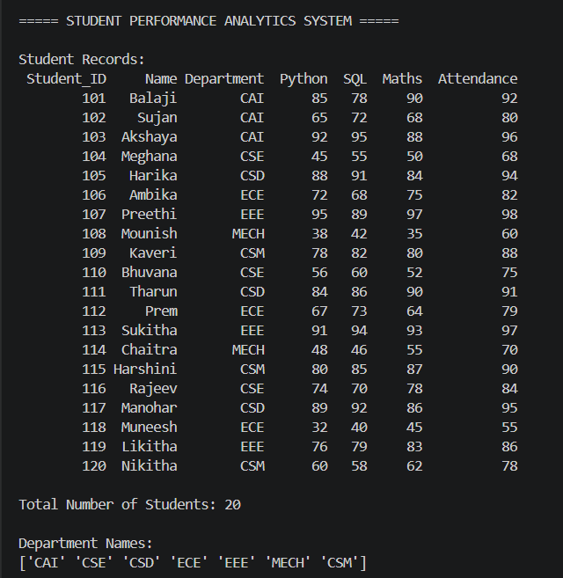
Figure 2: Student Marks and Grades
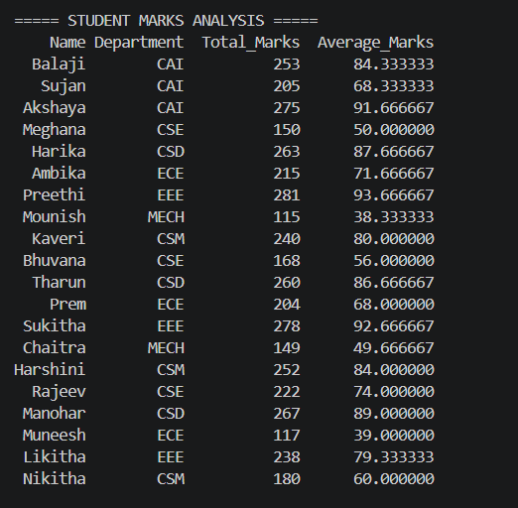
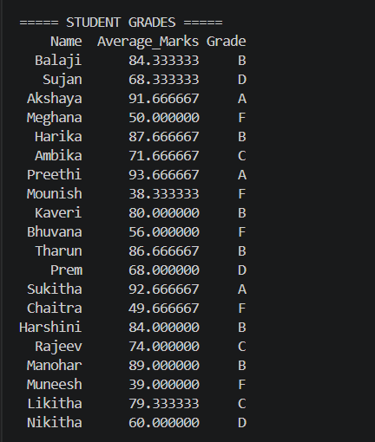
Figure 3: Pass/Fail Results and Class Summary
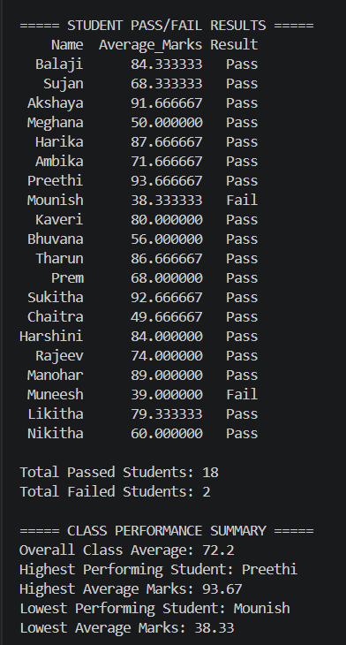
Figure 4: Subject-Wise Performance and Top Five Students
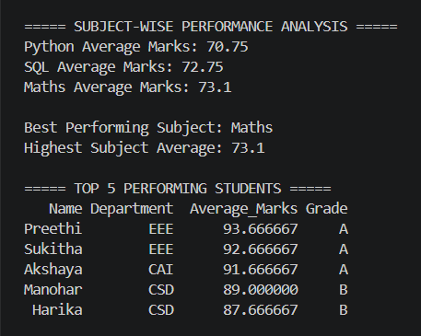
Figure 5: Attendance Analysis
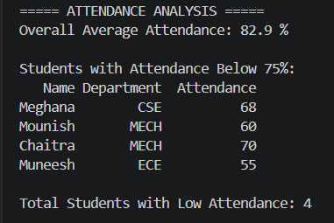
Figure 6: Department-Wise Performance
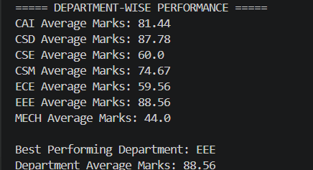
Figure 7: Project Files in Visual Studio Code
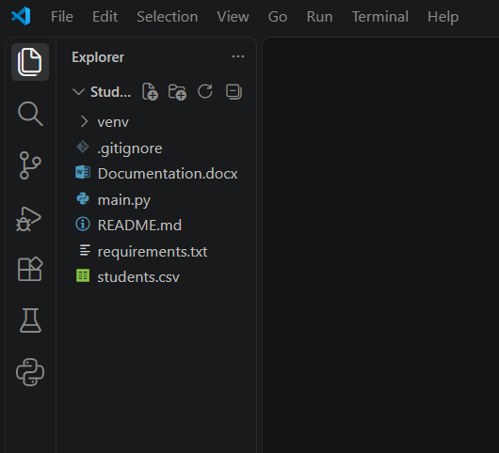

13. TESTING
The program should be tested to confirm that the analysis works correctly.

Test Case | Expected Result
Load the CSV file | Student records are loaded successfully
Calculate total marks | Marks from all three subjects are added
Calculate average marks | Total marks are divided by three
Assign grades | Each student receives a grade based on the defined criteria
Calculate pass/fail | Students are classified according to the average marks rule
Find top performers | Students are sorted in descending order of average marks
Analyze attendance | Students below 75% attendance are identified
Analyze departments | Average marks are calculated for each department
The expected results should be compared with the actual terminal output during testing.

14. ADVANTAGES
- Reduces manual calculations.
- Processes multiple student records efficiently.
- Provides a clear summary of academic performance.
- Helps identify students who may need academic support.
- Demonstrates practical applications of Python and data analysis libraries.
- Can be extended to analyze larger datasets.

15. LIMITATIONS
- The current project uses a CSV file rather than a live database.
- The results depend on the accuracy of the input data.
- The grading and pass/fail criteria are predefined.
- The program displays results in the terminal and does not include a graphical user interface.
- The analysis uses three subjects and a fixed set of student records.

16. FUTURE ENHANCEMENTS
The project could be extended in the future by adding more subjects, supporting larger datasets, generating charts, exporting reports, or developing a graphical interface. These are possible improvements and are not part of the current project implementation.

17. CONCLUSION
The Student Performance Analytics System successfully demonstrates how Python, NumPy, and Pandas can be used to analyze student academic data. The project calculates total and average marks, assigns grades, determines pass and fail results, identifies top performers, analyzes attendance, and compares department-wise performance.
Through this project, practical knowledge of Python programming, functions, loops, conditional statements, numerical calculations, and data manipulation is applied to a real-world educational use case.
The project provides a foundation for understanding basic data analytics and can be enhanced with additional analytical features in the future.

18. REFERENCES
- Python official documentation: https://docs.python.org/3/
- Pandas official documentation: https://pandas.pydata.org/docs/
- NumPy official documentation: https://numpy.org/doc/

19. PROJECT REPOSITORY
GitHub Repository URL: 🔗Student-Performance-Analytics-System
Or
https://github.com/akshaya615/Student-Performance-Analytics-System
Submission: The project source code, CSV dataset, README file, and documentation will be organized in the GitHub repository and submitted using the official EWB course submission form, as instructed by the trainer.

